# 



# School of InfoComm Technology

**Machine Learning**

Diploma in Data Science (DS)

Diploma in Information Technology (IT)

October 2023 Semester

**INDIVIDUAL ASSIGNMENT 1**

(30% of Machine Learning Module)

**Deadline for Submission:**

**10th Dec 2023 (Sunday), 2359 Hours**

|  |  |  |
| --- | --- | --- |
| Student Name | : |  |
| Student Number | : |  |
| Video Presentation Link | : |  |

**Penalty for late submission:**

10% of the marks will be deducted every day after the deadline.

**NO** submission will be accepted after 17th Dec 2023, 23:59.

**Machine Learning Assignment 1**

1. **Objectives**

In this assignment we will explore and analyze two datasets to understand the data and prepare the data for the machine learning modelling in Assignment 2.

* To conduct data preparation, exploration and analysis through visualization and statistical approaches
* To prepare the data ready for machine learning modeling
* To document the analysis and findings

1. **Datasets** 
   1. **HR Analytics (Classification Problem)**

HR analytics is revolutionizing the way human resources departments operate, leading to higher efficiency and better results overall. Human resources have been using analytics for years. However, the collection, processing and analysis of data has been largely manual, and given the nature of human resources dynamics and HR KPIs, the approach has been constraining HR. Here is an opportunity to try applying machine learning modelling in identifying the employees most likely to get promoted.

This dataset (**hr_data.csv**) contains employee personal information, education background, past performance and etc. Detailed information can be found in the below table. You can utilize all these variables to make prediction on whether the employee will be promoted or not.

**hr_data.csv**

|  |  |
| --- | --- |
| **Variable** | **Definition** |
| employee_id | Unique ID for employee |
| department | Department of employee |
| region | Region of employment (unordered) |
| education | Education Level |
| gender | Gender of Employee |
| recruitment_channel | Channel of recruitment for employee |
| no_of_trainings | no of other trainings completed in previous year on soft skills, technical skills etc. |
| age | Age of Employee |
| previous_year_rating | Employee Rating for the previous year |
| length_of_service | Length of service in years |
| KPIs_met >80% | if Percent of KPIs(Key performance Indicators) >80% then 1 else 0 |
| awards_won? | if awards won during previous year then 1 else 0 |
| avg_training_score | Average score in current training evaluations |
| is_promoted | (Target) Recommended for promotion |

* 1. **Airbnb (regression problem)**

Since 2008, guests and hosts have used Airbnb to expand on traveling possibilities and present more unique, personalized way of experiencing the world.

This dataset (**listings.csv**) describes the listing activity and metrics from year 2013 to 2019. The data file includes the hosts information, the condition of listed properties, the reviews and etc. Detailed information can be found in the below table. You can utilize all these variables to make predictions on the rental price of the listed properties.

**listings.csv**

|  |  |
| --- | --- |
| **Variable** | **Definition** |
| id | listing ID |
| name | name of the listing |
| host_id | host ID |
| host_name | name of the host |
| neighbourhood_group | region |
| neighbourhood | sub region |
| latitude | latitude coordinates |
| longitude | longitude coordinates |
| room_type | listing space type |
| price | (Target) daily rental price in dollars |
| minimum_nights | amount of nights minimum |
| number_of_reviews | number of reviews |
| last_review | latest review |
| reviews_per_month | number of reviews per month |
| calculated_host_listings_count | amount of listing per host |
| availability_365 | number of days when listing is available for booking |

1. **Suggested tasks**

You are suggested to tackle each dataset in the below FOUR steps.

Step 1: **Obtain the datasets** from POLITEMall and **Explore the Data**

Download the datasets (hr_data.csv and listings.csv) from POLITEMall. You are encouraged to utilize both statistical and visualization approaches to familiarize yourself with the datasets.

Step 2: **Cleanse and Transform the Data**

Are there any missing values? How did you handle them? Are there any outliers? How did you identify them and how to deal with them? Do you need to transform the Categorical Data into numbers? Do you need to scale the data or not?

Step 3: **Correlation Analysis**

Investigate the relationships between different features/variables. Which features are likely helpful for making predications? Did you create any new features/variables? Did you drop any features/variables and why?

Step 4: **Export the Data**

After you finish the above preparation tasks, export the newly created data into csv files (**hr_data_new.csv and listings_new.csv**) accordingly. We will be using these newly created datasets to build Machine Learning Models in Assignment 2.

1. **Suggested report format & content guidelines**

Write an **INDIVIDUAL** report with the following sections (see Table below). Sample content description is provided for each section. You are free to include other relevant information you deem necessary in the sections. You are strongly encouraged to include screen shots in your explanation, description and/or analysis.

*(Note: For a page with 1 inch margins, 11 point Calibri font, and minimal spacing elements, a good rule of thumb is* ***500 words*** *for a single spaced page)*

|  |  |  |
| --- | --- | --- |
|  | **Suggested Report Sections & Content Guidelines** | **Word Count** |
| 1. | Table of Contents | NA |
| 2. | Summary/Overview | 500 words |
| 3. | HR Analytics   * Problem Understanding * Data Exploration * Data Cleansing and Transformation * Correlation Analysis * Others   **Hint:** for this binary classification problem, do you have equal sized samples for the two classes? If not, how did you handle this? Stratified Sampling? | Min: 1000 words  Max: 3000 words |
| 4. | Airbnb   * Problem Understanding * Data Exploration * Data Cleansing and Transformation * Correlation Analysis * Others:   **Hint:** Do you plan to utilize all the samples to build a generic price prediction model? It is likely more effective to focus on a subset of data (e.g. certain region, certain price range and etc.) to build a customized price prediction model. | Min: 1000 words  Max: 3000 words |
| 5. | Summary and Further Improvements   * Summarize your findings on the two datasets * Explain the possible further improvements | Min: 500 words  Max: 1000 words |

1. **Deliverables**

For this assignment, you must submit all the following:

1. A softcopy **Final Report** (in Microsoft Word / PDF format)

* Submit in “**Assignment 1 Report Submission**” folder in POLITEMall
* Saved in Microsoft Word/PDF format with the following file naming convention:

<Student ID>_<Name>_ML_ASG1_AY2310

e.g. s2001111A_JohnKhoo_ML_ASG1_AY2310

1. The completed **“ML_ASG1_AY2310.ipynb”** Jupyter Notebook File

* Submit in “**Assignment 1 Jupyter** **Submission**” folder in POLITEMall
* The Jupyter notebook is to be clearly labelled using markdown cell indicating the section.
* Saved the completed Jupyter Notebook File with the following file naming convention:

<Student ID>_<Name>_ML_ASG1_AY2310

e.g. s2001111A_JohnKhoo_ML_ASG1_AY2310

1. Link to **Video Recorded Presentation**

* You are required to do an **online presentation** and share your findings. The presentation **should not exceed 10 minutes**. The presentations which exceed the allotted time will be penalized.
* You are encouraged to use your **Jupyter notebook** for your presentation.
* Students will make use of the video assignment app, powered by Bongo, to capture their presentations. Each student is to practice the presentation in advance to ensure completion **within 10 minutes**. The recording must include both webcam (clearly showing the student's face for authentication) and slides or codes (whichever is applicable).
* Select the **RECORD VIDEO** option and choose **CAMERA + SCREEN** as shown in the figure below. The figure may differ with the constantly update of the Bongo software, hence students may see a different layout but general steps should still apply.

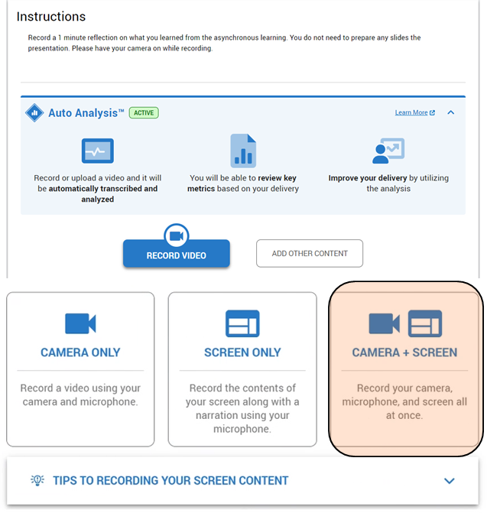

* After recording the video, click save (as shown below) and it will be ready for students to append it for submission.



* Select the video by clicking on the Star and click **SUBMIT**.

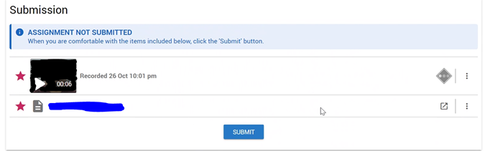

All sections must be completed.

Submit the deliverables no later than **Sunday 10th Dec 2023, 2359 hours** in POLITEMall. Late submissions of assignment-based coursework component without leave of absence (LOA) for the module will be subjected to the late penalty.

**Note: DO NOT PLAGIARIZE (please refer to Ngee Ann Polytechnic Plagiarism Policy** [**webpage**](https://www1.np.edu.sg/clte/antiplagiarism/policy.htm) **for more information)**

1. **Grading Criteria**

|  |  |  |
| --- | --- | --- |
|  | **Grading Criteria** | **Component**  **Weightage** |
| **Presentation** | 1. Quality of work 2. Flow of presentation based on content guidelines (see section 4) 3. Quality of presentation, Quality of analysis and discussions via markdown text 4. Presentation and articulation skills | **50%** |
| **Final Report** | 1. Quality of work 2. Completeness of report based on suggested report sections and content guidelines (see section 4) 3. Clarity of report, Quality of discussions, Use of proper visual aids and Use of proper grammar 4. Quality of recommendations for further improvements | **50%** |